**Institute of Engineering & Management**

**Department of Computer Science & Engineering**

**Communication Engineering Laboratory for 2nd year 4th semester 2018**

**Code: CS 491**

**Date:** 22/02/18

**ASSIGNMENT- 6**

**Experiment Name**: Design a monostable multivibrator using 555 timer

**Theory:** A monostable multivibrator (MMV) often called a one-shot multivibrator, is a pulse generator circuit in which the duration of the pulse is determined by the R-C network, connected externally to the 555 timer.

**Circuit Diagram:**

**Operation of the circuit:** Initially, when the output at pin 3 is low i.e. the circuit is in a stable state, the transistor is on and capacitor- C is shorted to ground. When a negative pulse is applied to pin 2, the trigger input falls below +1/3 VCC, the output of comparator goes high which resets the flip-flop and consequently the transistor turns off and the output at pin 3 goes high. This is the transition of the output from stable to quasi-stable state, as shown in figure. As the discharge transistor is cutoff, the capacitor C begins charging toward +VCC through resistance RA with a time constant equal to RAC. When the increasing capacitor voltage becomes slightly greater than +2/3 VCC, the output of comparator 1 goes high, which sets the flip-flop. The transistor goes to saturation, thereby discharging the capacitor C and the output of the timer goes low, as illustrated in figure. **Thus the output returns back to stable state from quasi-stable state.** The output of the Monostable Multivibrator remains low until a trigger pulse is again applied. Then the cycle repeats. Trigger input and output voltage are shown in figure.  
  
The time during which the timer output remains high is given as tp = 1.0986 RAC where RA is in ohms and C is in farads.

**Observation Table:**

DC = 88.3% ; Ttrg = (1/f)*(1-DC)  
 =(1/10)*(1-(88.3/100))

|  |  |  |  |  |
| --- | --- | --- | --- | --- |
| **No. of Obs.** | **R** | **Calculated value of T** | **Oscilloscope Value** | |
| **T** | **Vout** |
|  |  |  |  |  |
|  |  |  |  |  |
|  |  |  |  |  |

**Waveform:**

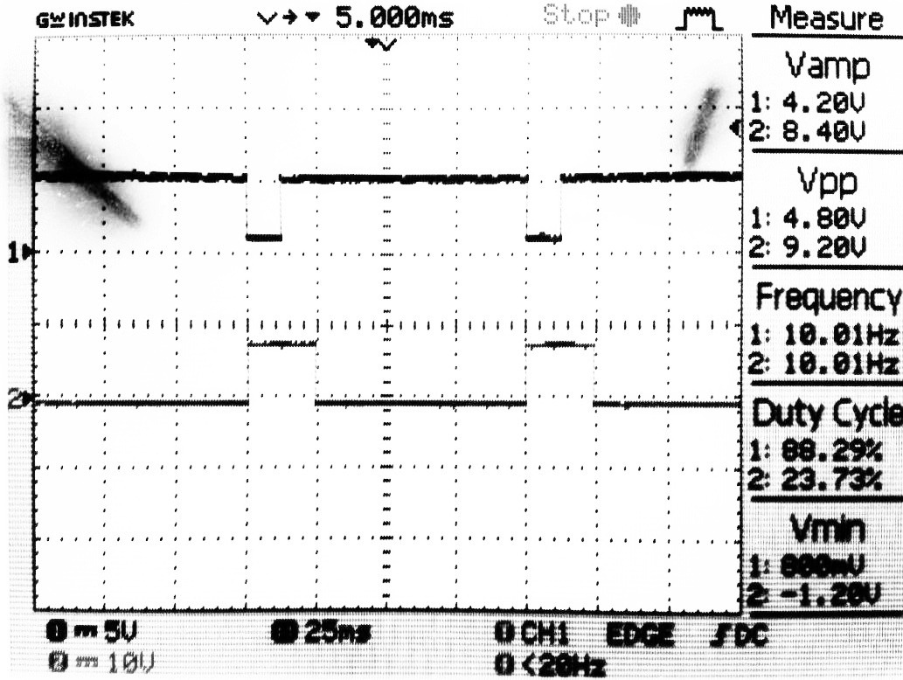

**Conclusion:** In this experiment we have implemented monostable multivibrator using IC 555 timer circuit.